**CYBR472 Lab 06: Keyword Search and Analysis**

**greenthom – 300536064**

Thomas Green – Lab06 – January 1st - 300536064

**Assessment Overview**

You will be using Autopsy in the case study. You will demonstrate your ability to create cases in Autopsy, perform different types of keyword searches and analyze the results. This lab is worth 6% of your total course grade.

**Submission Requirements**

* Heading for the report with lab number, birth month, your name and student ID
* Screenshots as indicated (with personalization requirements)
* Only write something when explicitly instructed to do so
* There are 6 questions in total
* Submit as a single PDF document

**Part 1: Creating a Forensic Case in Autopsy (20 marks)**

Complete the lab but when creating your case please:

* Use your full name as the examiner in the Optional Information window
* Include your student ID in the case number field (e.g., FOR_LAB_006_12345678)
* Use the keyword list name “For_LAB_006_[YourLastName]”

Document your process by providing the following screenshots:

**1) Screenshot of step 3 showing your case creation with your name and student ID visible (5 marks)**

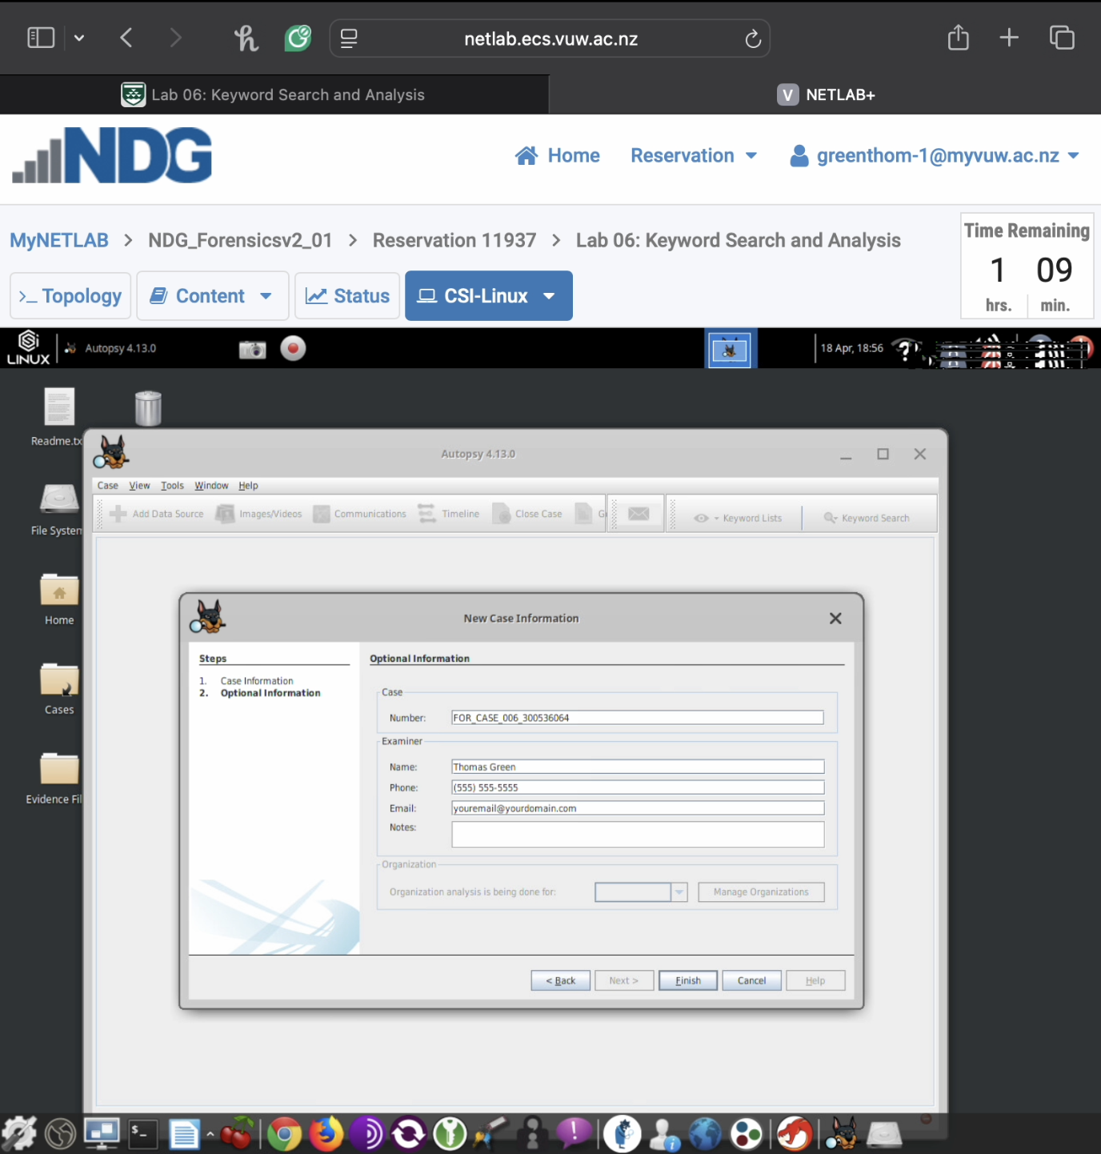

**2) Screenshot of step 18 showing your keyboard list creation with the following visibly added keywords (10 marks):**

* **Your birth month as an Exact Match term (e.g., “January”)**
* **The first three letters of your last name as a Substring Match term**
* **A Regular Expression search term with the pattern “Stored*”**

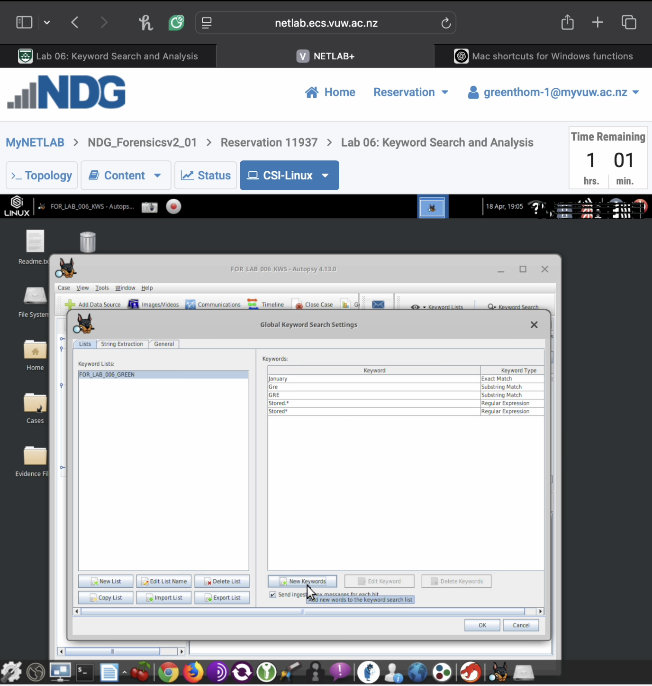

**3) Screenshot of step 24 showing Autopsy’s successful importing of the evidence file (5 marks)**

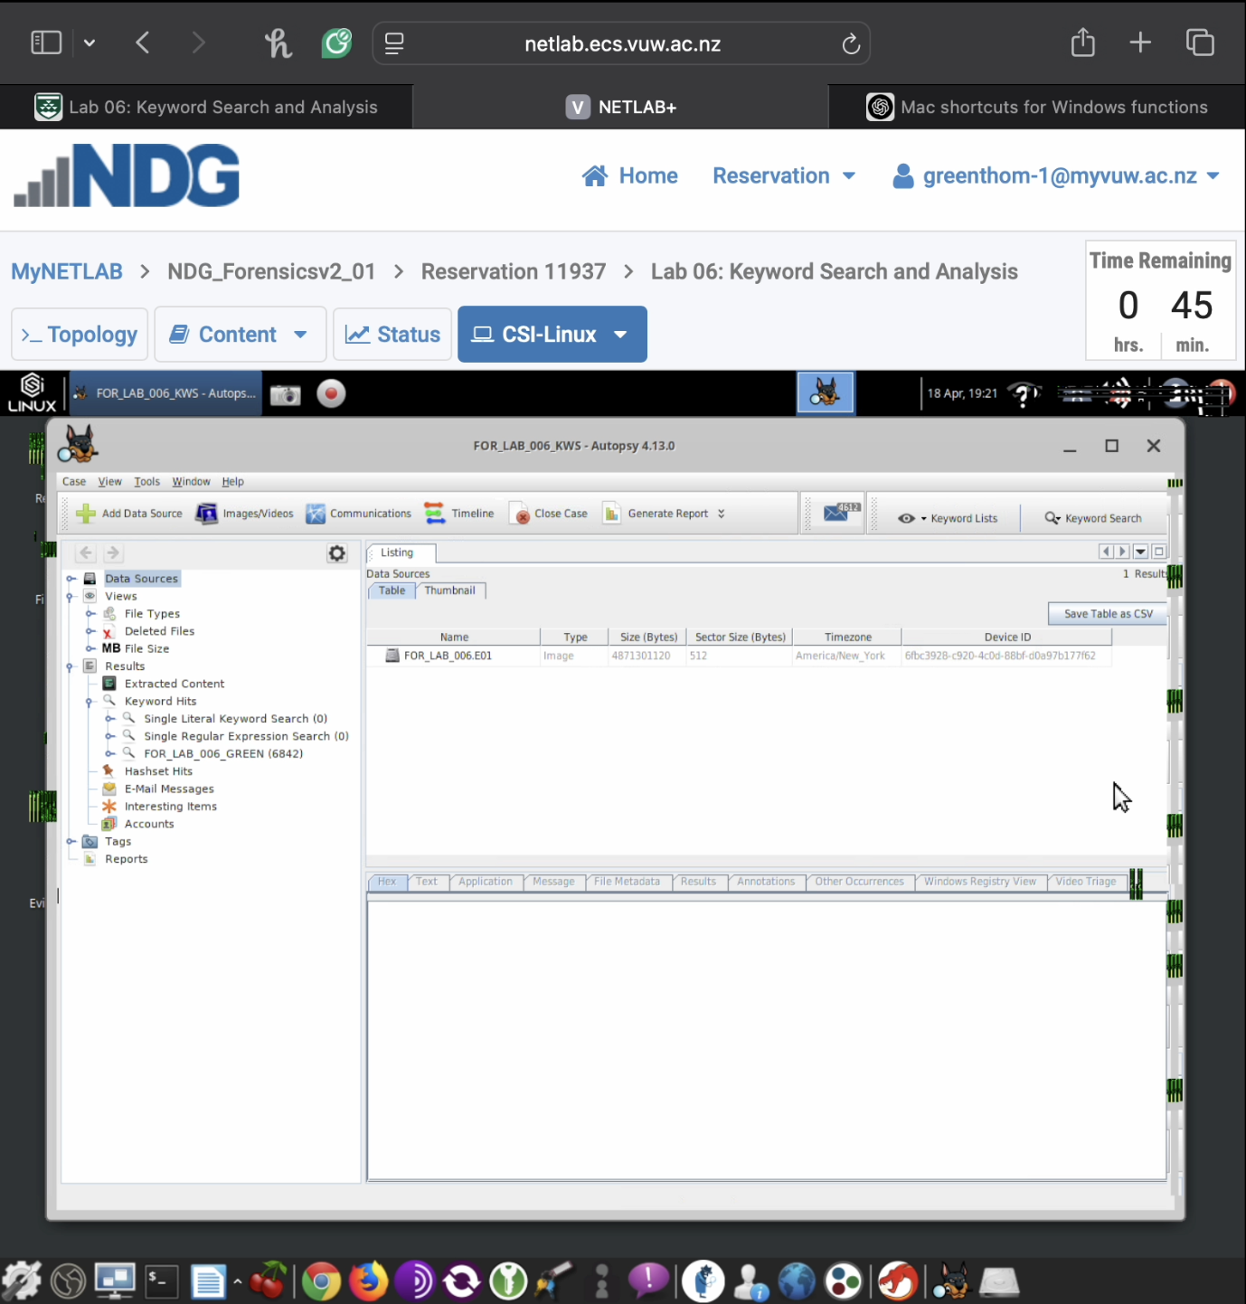

**Part 2: Keyword Search Results Analysis (30 marks)**

Perform keyword searches with your personalized terms and document your findings:

**1) Screenshot of step 27 showing search results for your birth month keyword (if no results appear, use “January” instead) (5 marks)**

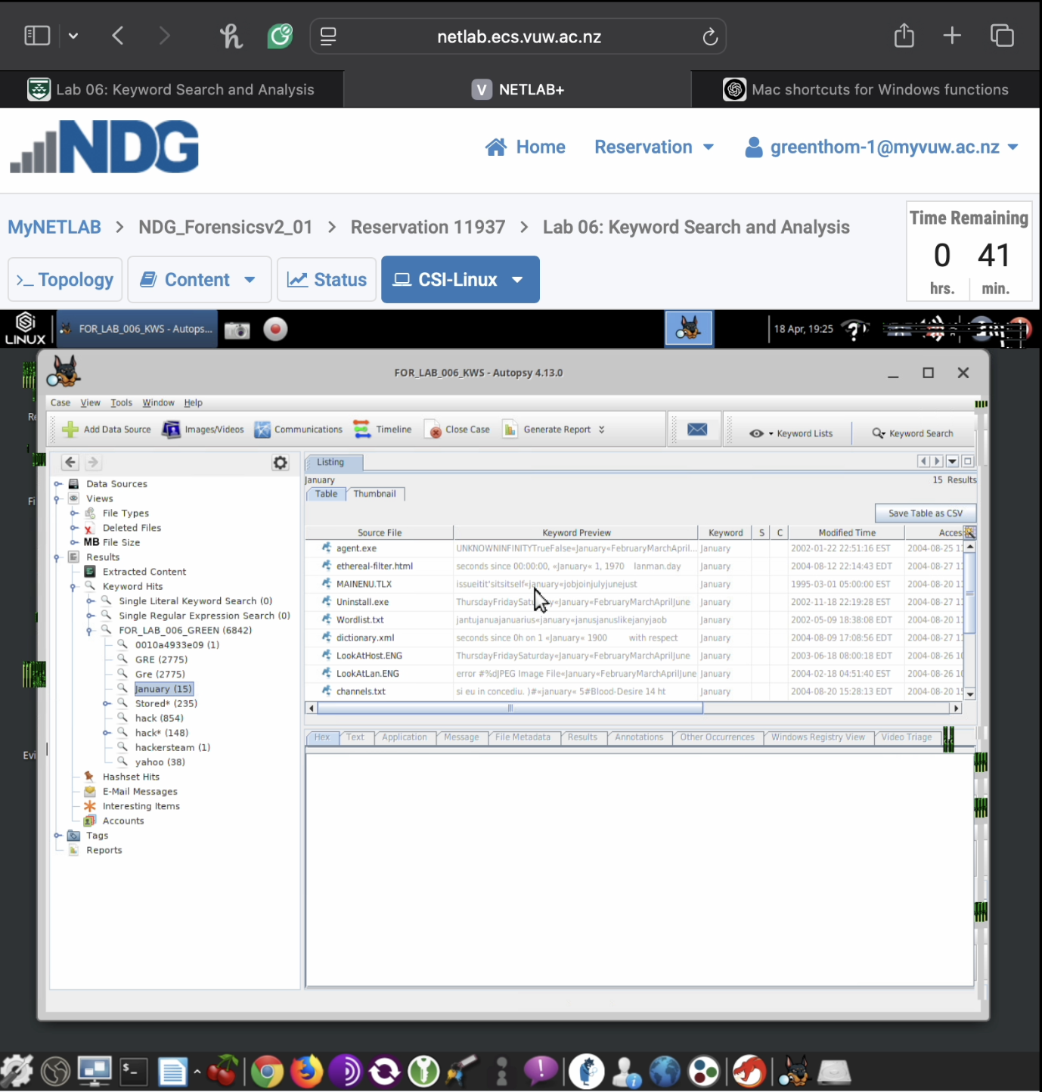

**2) Screenshot of step 29 showing search results for your substring match term (if no results appear, use “hack” instead) (5 marks)**

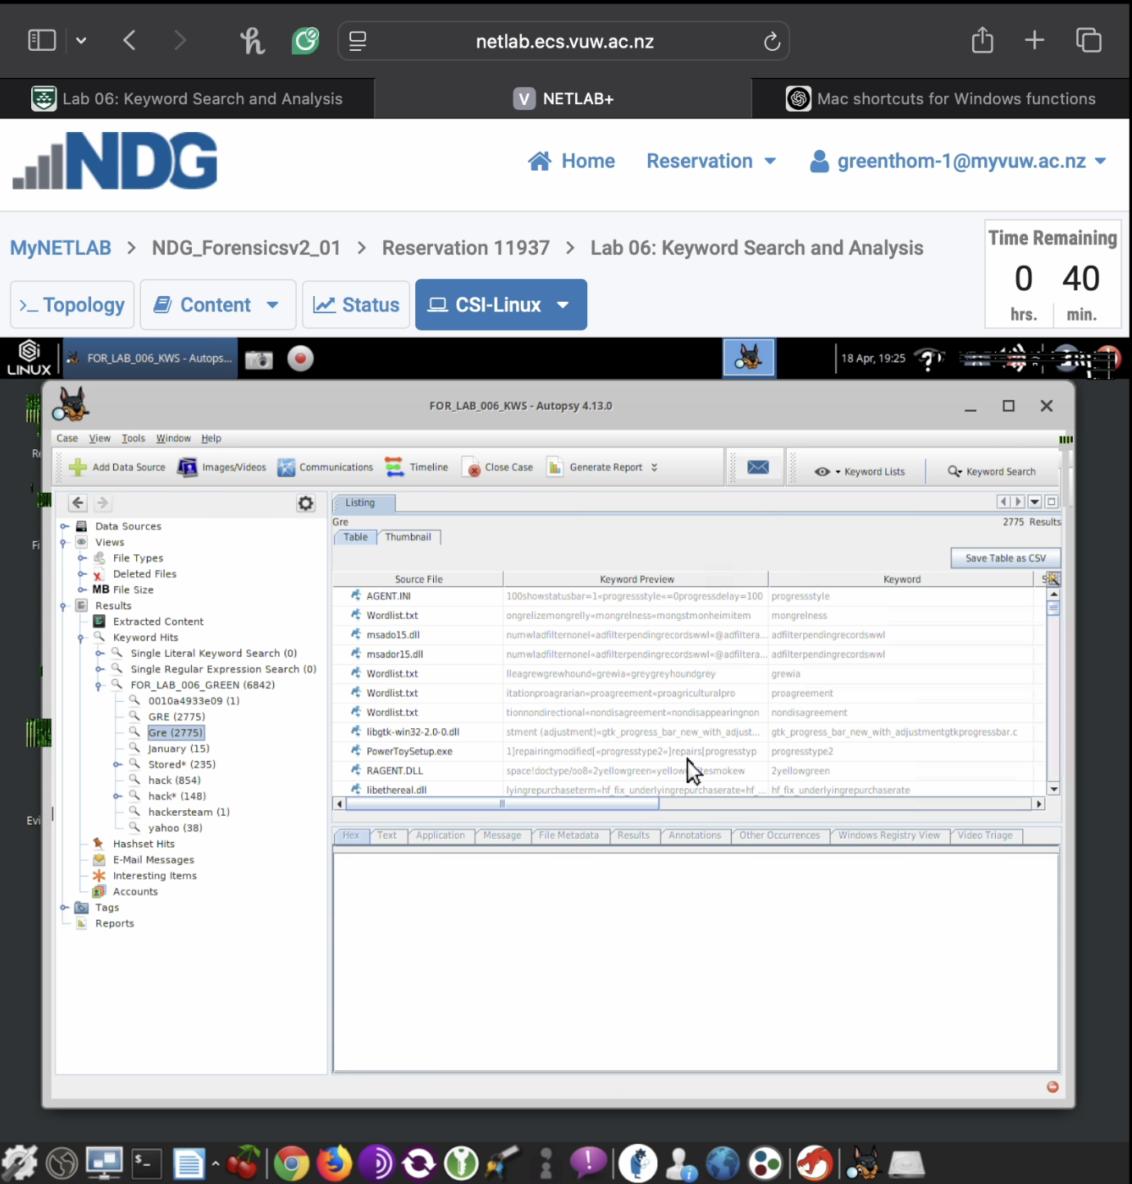

**3) Screenshot of step 30 showing search results for your regular expression term (5 marks)**

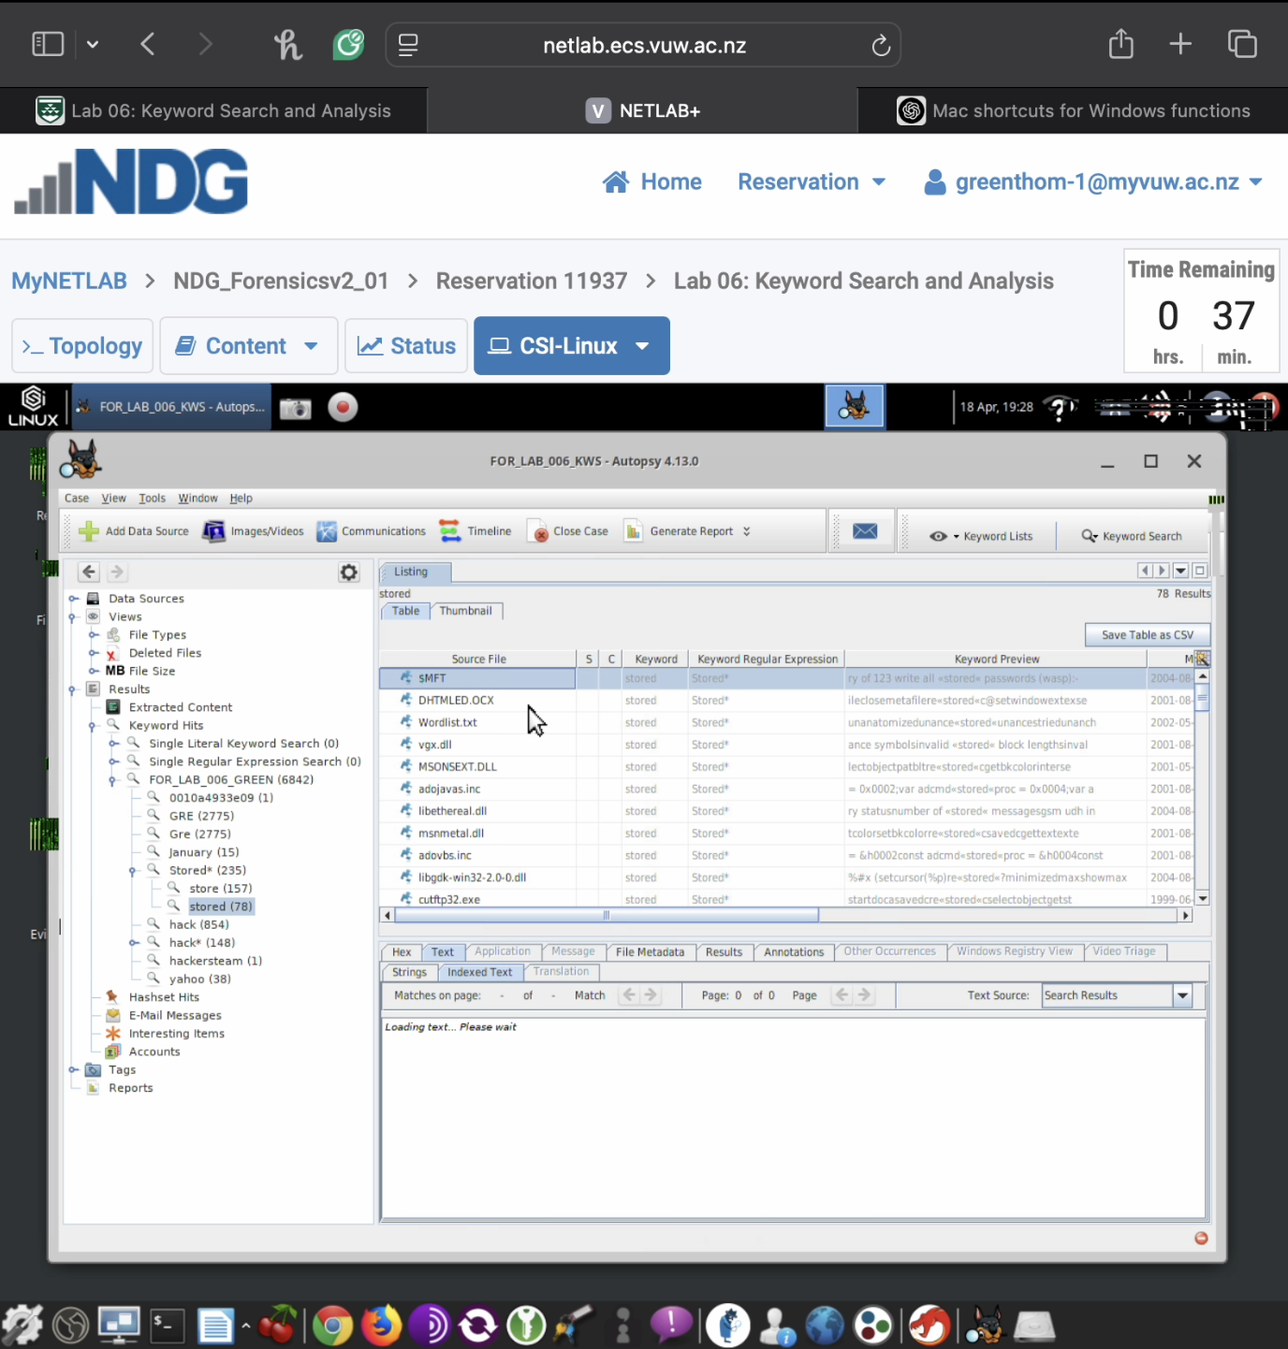

**4) Screenshot of step 30 showing the contents of a specific file containing one of your keyword hits (5 marks)**

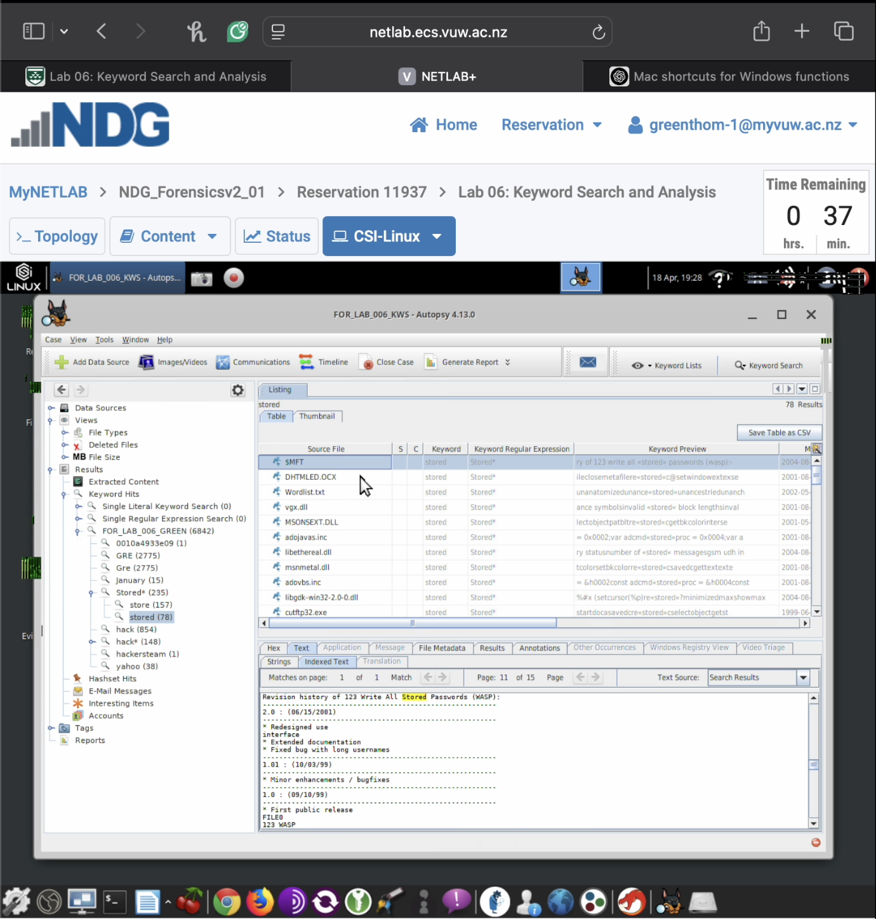

**5) Screenshot of step 32 any file content your discovered during your keyword searches and explanation of why the content might be of forensic interest (5 marks)**

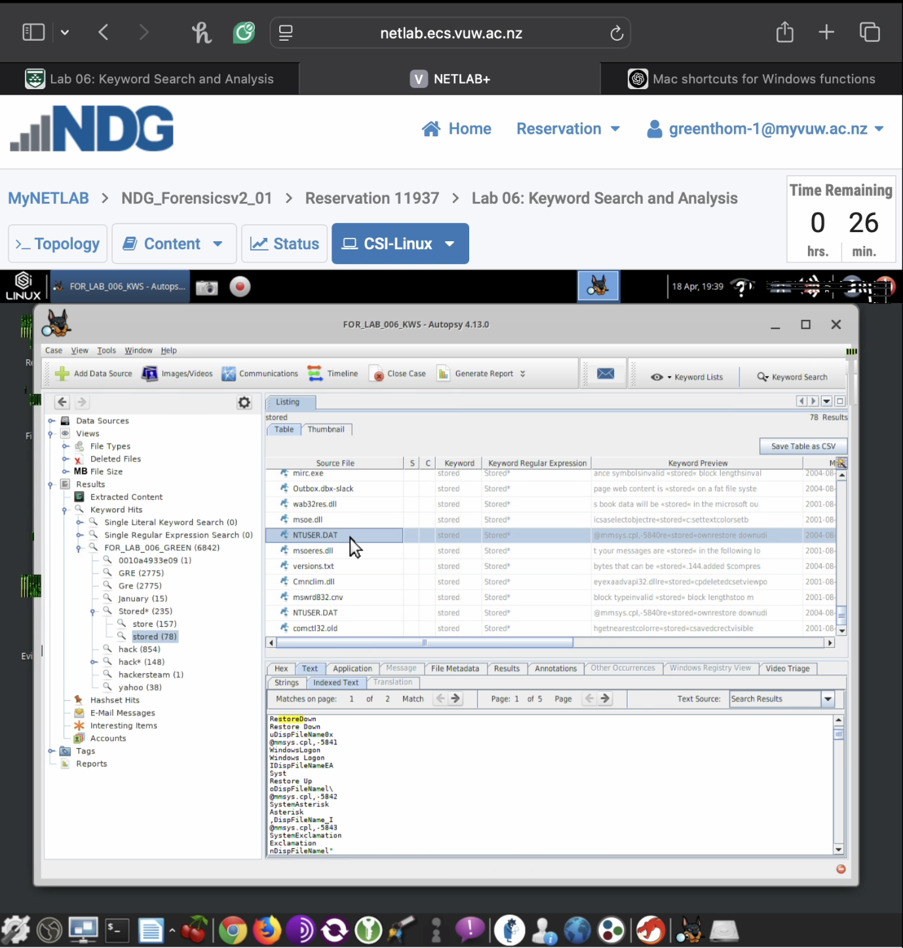

Discovered a NTUSER.dat file. This file contains critical data such as user preferences, recently accessed files, typed URLs, and program execution history. This helps establish what the user was doing the system. The keyword “stored” is seen in registry-related context which may indicate saved credentials, login sessions, or cached settings, which would be potentially useful in uncovering unauthorized access or tracing user behavior. The .dat file is tied to a specific user profile, its contents can help attribute actions or files to a specific individual, which is crucial in forensic investigations.

**6) Provide a screenshot of step 35 of you performing an index search for the term “anon.*” and the results it returns (5 marks)**



